WEBSITE UPDATES
NEWS FROM THE FIELD
RUTH SOMMERVILE CLINIC

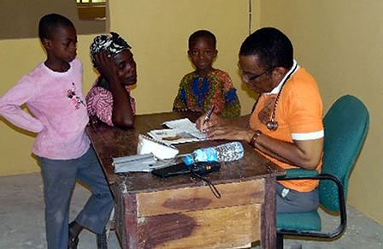
On the 18^{th of} August, the clinic was invited by the National Tuberculosis and Leprosy Control Progrmme (NTBLCP) for a three days training for some private and public health facilities in Ebonyi southzone, which was held at DBASE hotel Amasiri, Afikpo north. The clinic was duely represented.At the end of the training, an MOU was shared to all the facility in attendance for implementation, of which after that, the NTBLCP will supply materials and drugs for the services to take off in all the facilities who are yet to start the TB services.
On first of October at exactly 2.30am, the clinic had a successful delivery of a baby Boy from one of her antenatal patients and as if that was not enough, another delivery also took place in the month of October successfully. Truly God is rewriting the story of the Akaeze people and her environs by these testimonies. The baby and their mothers are healthy. Praise the Lord. Keep praying as the clinics still need the service of one more Nurse and a more steady medical Doctor.

TETMI HIGH SCHOOL
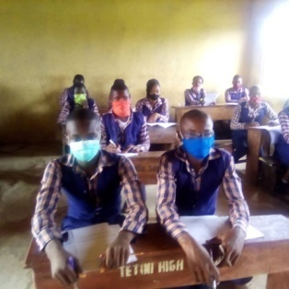
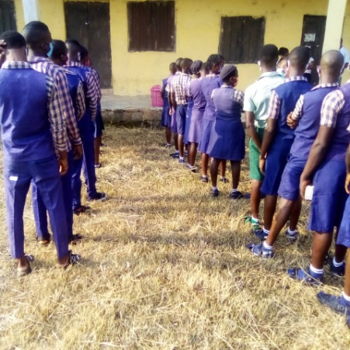
The management of TETMI High School has was on high Spirit to see the schools reopen again after a great period of lock down due to the pandemic. The held several consultative meetings through the e-communication systems and was set for their face to face meetings immediately the lockdown was eased. They were able to get themselves with the necessary equipments needed to keep the environment safe for the return of the pupils especially the examination classes. They provided enough sanitizers and hand washing buckets with water and then have the students come alongside with their nose masks. Thus, the school participated in the last S.S.C.E and JSSCE examinations successfully. After that the full resumption of the school took place in accordance with the government and the COVID 19 team instructions.
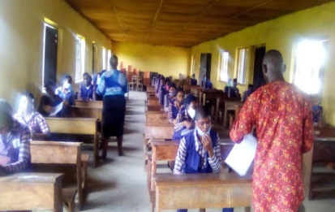
There was a surge of students returning to school and academic activities began immediately, though there was some set back due to the resignation of some of the teachers during the long lock down periods, but thank God who gave wisdom on how to replace them and move the school forward. The burden students al came back in full, likewise the Day students. In addition to academic activities, spiritual activities took another shape as the Lord brought in contact to the school a student ministry missionary, who works with the Peace house. This brought a great opportunity for more evangelist work being carried in the school. He started with the dormitory students and at the first meeting, almost all the students gave their life’s to Christ and by second meeting, a follow up bible class began. From the subsequent Sunday, they began a Sunday service where the students moderate and the missionary shares the word. It’s been great times of fellowship and discipleship in the school. He also ministered to the entire students during her Thursday Moral Instruction period and about 18 students gave their lives to Christ and then joined the follow up class too. Join us to keep praying that God will help the students to understand His word and guide them by the power of the Holy Spirit. Also pray that God will provide funds for the parents of most of the students so as to pay little fees being collected for their education and that God will grant scholarship to the much indigent ones from very poor family. Let God give the teachers the strength and courage to move on despite the difficult situations they find themselves.

CHURCH PLANTINGS
TSEGUSE, KWANDE, L.G.A OF Benue state.
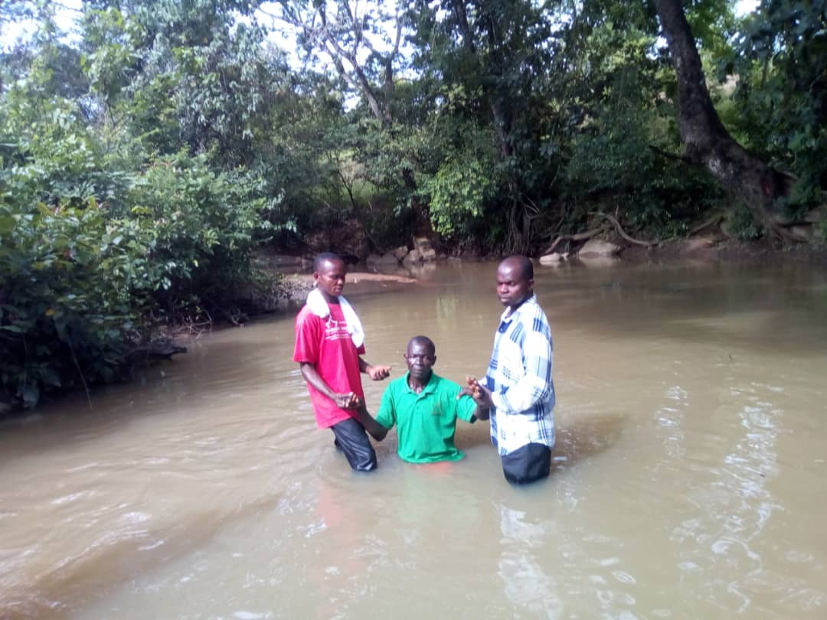
The Lord is adding more souls to the believers in this land. The evangelistic outings and visits has brought several families to Christ because of the Love of God demonstrated to them.
A MAN who is engrossed in idol worshipping surrendered his life to Christ and dropped his idols to follow Christ. He is now undergoing follow up to help him in his new found faith. Pray that God will satisfy his spiritual hunger and fill him with the knowledge of His word. Ask God for the salvation of more men in the land.
The love seen among the members of the TSEGUSE church has brought unity among the families of Ephesan TSEGUSE. This has given the church a great testimony in the land. Praise God for such great testimony and Ask God to let His Oil flow upon their heads to sustain such love. Pray for a member who had surgical operation in a hospital far from from the village and has been heald but remains in the hospital for about a year now due to inability to pay the hospital bill if N130,000. Pray that God will intervene and open door of financial provision for the family, so that the member will be released to come back home
AGEL/AGBATSE, KWANDE LGA, BENUE STATE.
Thank God for various evangelistic outreaches that have led to the salvation of many souls. Outreaches ranging from house to house, film outreach and help outreach. Now many of them are going through follow up classes. Pray for their spiritual growth. Some of the believers are committed in their discipleship class and have been part of the evangelistic movement, since after being trained on Evangelism by Missionary John Abenga.
Pray that the Lord will fill them with His grace and power as they move to conquer the land. Pray against the forces of darkness that is trying to raise their heads against the work of God in the Land. Ask God to pull down their strong holds and destroy them :
The wife of the missionary, Mrs Agatha Abenga has been of great ministry help to the husband, in handling the discipleship and bible study and Sunday school classes. She recently lost the father and desires our prayers. Pray for more of God's grace upon her and fullness of His power. Ask God to take her to a higher spiritual ground and reveal Himself more to her. Pray for God's comfort over the death of the father.
ASAGA AMANGWU
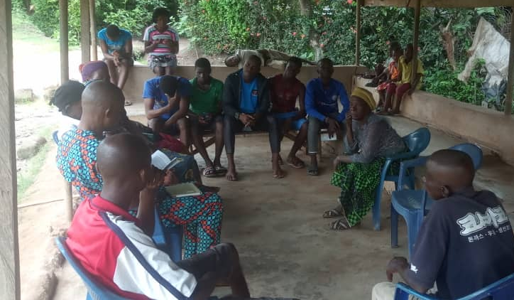
A village that rejected our missionary the first time we sent one there. But when TETMI brought medical outreach they opened their doors and then latter provided an accommodation for the missionary and a place of worship.
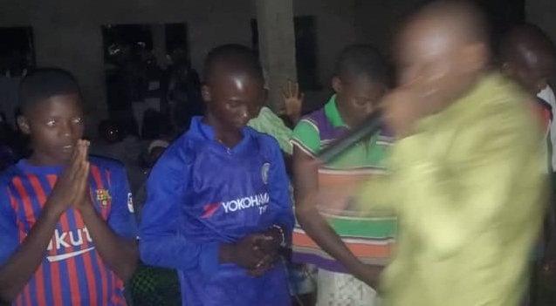
Our outreach there was welcomed by the chief of the village and thefirst night outreach started like a snail walk but surprisingly by the ending of the film outreach many youths turned out and about 12 adults gave their lives to Christ. The village is filled with a lot of youths roaming about and without Christ.
ON THE second day had the team engage the converts on a follow up activities where their attendance showed a great hunger for God's word. By evening another outreach session took place with specially presentations on Holy Spirit empowered life. Special prayer sessions were carried out. Pray that God will raise their hunger for Him and His word in their heart. Pray for complete yieldedness to the Holy Spirit work in their life, so as to live a victorious Christian life.
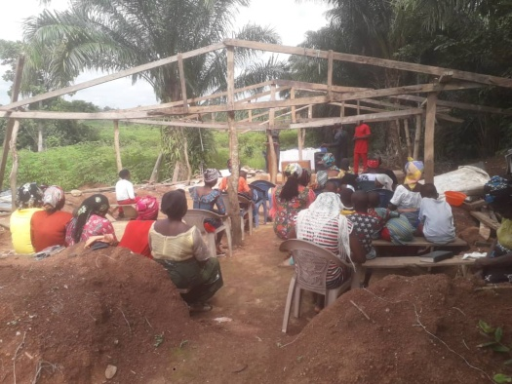
The second night of the outreach after film show, people were prayed for filling of the Holy Spirit to live righteously. There was miracles of divine revelation and healings. The second day afternoon meeting was for follow up fellowship where their salvation was made sure through the study of the Word and prayers.
Sunday service was done in their church building which is still under construction. The heat of the sun was direct on us as we fellowship though it tried to destabilise the meeting. But God gave them testimonies of salvation reassurance. Last week they were beating by rain too. We pray that God will raise support for them to roof the building before next week Sunday.

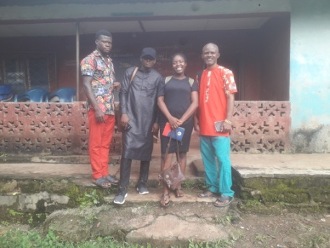
The outreach Team to Asaga AMANGWU back home now with testimonies of God's great deliverance upon the people of the Land who came out during the outreach. With great results of healings deliverance, prophecies, warnings, blessings and finally the salvation of all who gave their lives to Christ. On the last day of the outreach, the people were yearning for more of God in their lives as they willingly submitted to follow Christ. The youths were seen desiring that Jesus be the Lord of their lives, the women were seen and heard praising God for great deliverances while the chief who did not attend but heard what God is doing, called at late hour on our way out of the village for Him to be revisited and prayed for but we were already on our way home. A young boy who has been a cultist confessed at the hand of the Lord on him and he was saved. Some strange things that happened was the exposure and confession of many young girls who had marine spirit. They were also delivered and led to Christ.
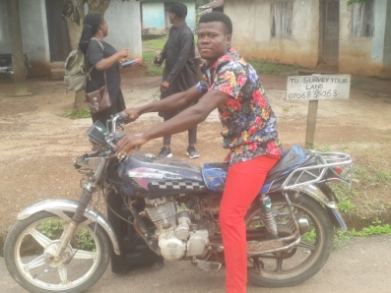
But there is truly great work for the missionary, in the area of follow up and serious concerted efforts to them because of where they are coming from. Some bibles will be need to make it easier for those who could read a little to start ingesting the word of God so as to grow and become stronger in faith. The missionary shall need your support to put in order his motorcycle in order or get a new one to move round the village for his visitations and ministry to these saved souls. He shall need your prayers for Him to meet up with the demand this great harvest is posing on him.
The missionary shall need our support to complete the roofing the church building needed for the discipline of the saved souls. Seeing also that most the people are poor villagers, they are contributing their little and the building is going on at a snail speed. But with this harvest, it is very necessary that this place be put in order, so that sun shine will not be heavy on them as it was last Sunday nor the rain falling on the members who came to church as it was last two Sundays. May God touch you to respond.

BECHEVE LAND IN KWANDE L.G.A, BENUE STATE.
We are working among the Becheve people in Benue state. Their common languages are pigeon English and Becheve Cultural practices amongst the Becheve people.
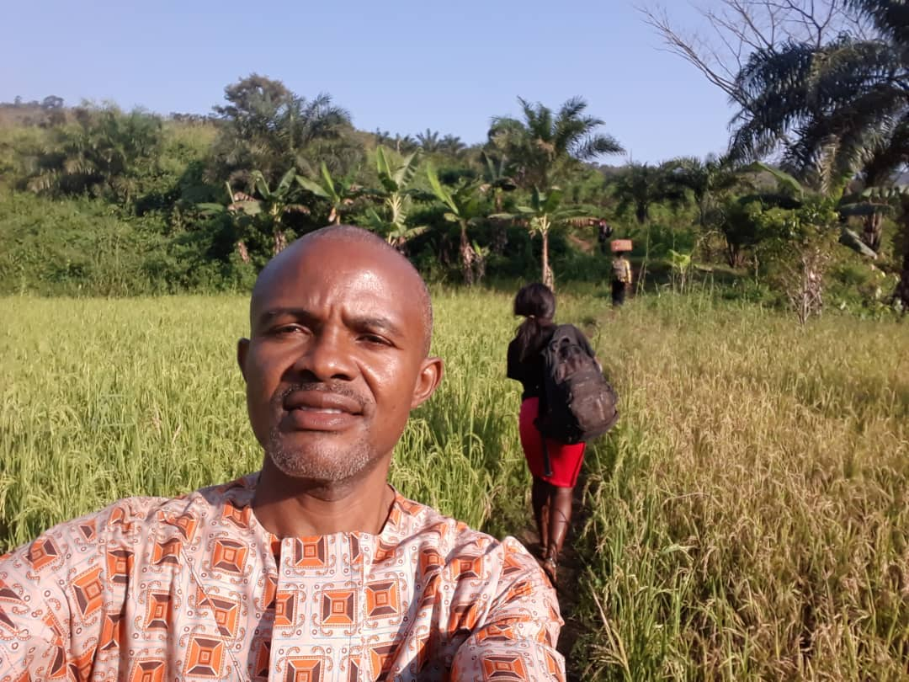
The people are predominantly farmers farming banana/plantain, cocoyam and animal rearing mostly Fulani and few indigenes. They have low level of education and high rate of child birth mostly by youths and teenagers. They have low regards for their wives due to some cultural practice called "Money woman Marriage" due to high rate of poverty in the land, a man who cannot meet up with his financial needs and his wife is pregnant or he has a little daughter can borrow money from another using his daughter as a collateral. (In the case of the pregnant wife the borrower enters agreement with the lender if the child turns out to be a girl she will be used to settle the dept, after raising the girl child to age 9-11 she will be handed over to the lender as his wife) as such you will see an elderly man with a girl young enough to be his grand daughter as a wife. In this practice a man can have as many wives and children as they can. Though the government came into the matter and the practice has reduced but some are still doing it secretly. ( you can go to YouTube and type "money woman among the Becheve" for further information about this practice.) Also they believe a diabolic practice of cleansing when a woman is pregnant and about to deliver her mother will match her naked for ritual cleansing to enable her give birth successfully and for the child not to die as an infant. They fear not to lose their children at infant age even some nominal Christian are involved in this practice. Witch craft practices is also very high and much drinking of alcohol. The youths are just roaming about jobless without doing anything.
Pray that the Lord will save this land from this enslavement and give them the freedom that comes through Jesus Christ.
Ask God to raise the value of women in the land by raising females folks who do exploits that will save the land from one hardship or other.
Pray for the Lord will visit the men in the land especially their leaders and show His love to them that will translate to their having deep love for the female folks and not used them as slaves. Pray for the prosperity of the GOSPEL in their midst.
The work in Becheve is trying to become A GATEWAY into Cameroun as clarion calls have been coming for us to extend the ministry work into the country. There have been several outreaches to Cameroun thereby establishing a preaching point there.
Pray earnestly for God's guidance, provision and protection, for the people too seems aggressive.
Pray that God will raise a Labour force that will be sent fully into the Land.
Pray that God will go before us and soften the hearts of the inhabitants, making them ready for the gospel.
BRANCH (UGEE- MDALAV)
The people of branch banned the missionary from preaching and praying going house to house but that any who desires to be prayed for should go to the church to meet him. This was because his going house to house to pray affects the shrines built in every compound and the gods complain. He obeyed and restricted his ministry in his church. But the challenges the inhabitants are going through could not but cause them to keep coming to the church, so much more that today, that ban has been lifted and he has started evangelizing freely again within the community and people are getting saved.

UMUNKPOR, ISIALA NGWA L.G.A, ABIA STATE
The community is characterized by cult activities by the youths which have ravaged the youths of the land. Recently the cult leader died and this has created a lot of fears in the hearts of the youths of the land. Pray that God would use this death to draw many of the Youths to himself as they think of life after death. God has also delivered Sister Amarachi Chinyere from demonic oppression which has lasted for one year but now through prayers, she has been set free. The church revival and harvest comes up soon, pray that God will use it to restore more lifes and challenge the believers to grow in their faith in Christ.

BEBUABIE, IN OBUDU L.G.A OF CROSS RIVERS STATE
This land is filled with witchcraft activities. The missionary have so much been attacked but he never gave up as the Lord keep giving him victory. He has been hit in the middle of the night by unknown hand, he fainted but latter recovered. He has been beating by snake, The wife has been attacked but God gave her victory. Some of the believers have had their own pinch of the attacks but the power of God delivered them. The church have also been receiving opposition from the villagers and old denominations, all stirred up by the witchcraft activity in the land. They swore that they will not allow any new evangelical church to thrive in their land. But the church keeps moving forward, drawing more souls to Christ and discipling believers. Miracles of healings and deliverances keeps going on and now new church planting to begin in a nearby village. Pray that the believers be strengthened in faith in the midst of many challenges and give the missionary boldness and courage as he confronts the evil powers in the land, till God gives him victory all the time. That the Love being shown to them by the group will spring forth sincere hunger for God in their lives. Pray for those undergoing discipleship in this group will grow to become Instrument in God's hand. Pray for more understanding of the scriptures and God's revelation of Himself more to them.
Pray for wisdom upon the church group as they plan on how to empower some of her members who are financially down and seeking for job.
HUMAN RESOURCES EMPOWERMENT
LEADERSFOR COHORT
As the world goes through a global lockdown, the minutest thing has been affected. Businesses, workplaces, religious activities, organizations have been sorely hit by the Covid-19. Christian miss ions organizations globally have also been affect directly and indirectly by this pandemic. TETMI as a mission’s organization is not left out of this effect.
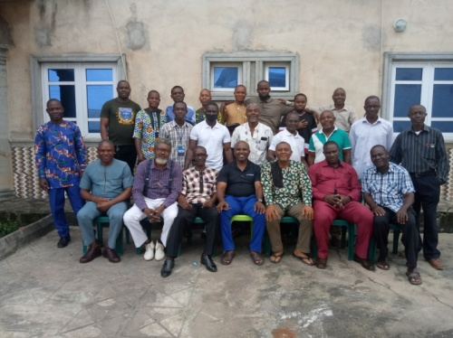
Operations in TETMI from the top to the grass root have suffered setback and have had to reorganize its plans for the year to achieve the ministry goals and objectives. One of such plan is training for mission workers, and pastors.
The LEADERSFOR NIGERIA COHORT is a training dedicated to equipping church Leaders with skill to be able to handle the management of church in this 21st century, to help them align properly with the global purpose of the church, through the teaching of sound doctrine via scholarly approach. One of the major aims of this training is to help our local church leaders to build a healthy church where every member is inclusive.

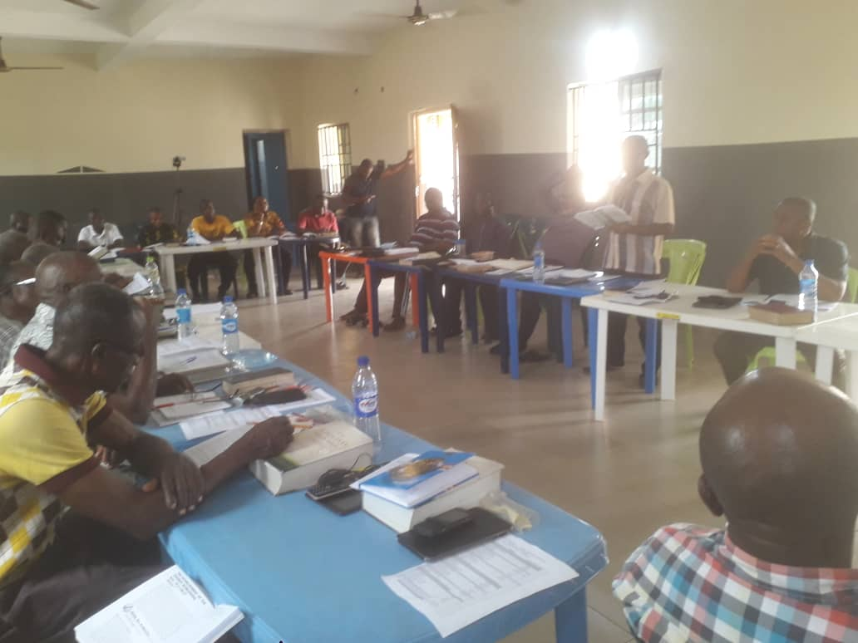
The last LEADERSFOR training held in the month of June had no Canadian facilitator participate physically because of the travel restrictions due to the pandemic. However, we had the opportunity to explore other options. The most prominent was the use of the Zoom Application to have them hook up with us and facilitate some sessions. Over 20 church Leaders are involved in this training. The next LEADERSFOR training will be coming up in the month of November 2020. We are expecting to have doubled the number in participation. This is because each participant is expected to come with a one person who they are mentoring.

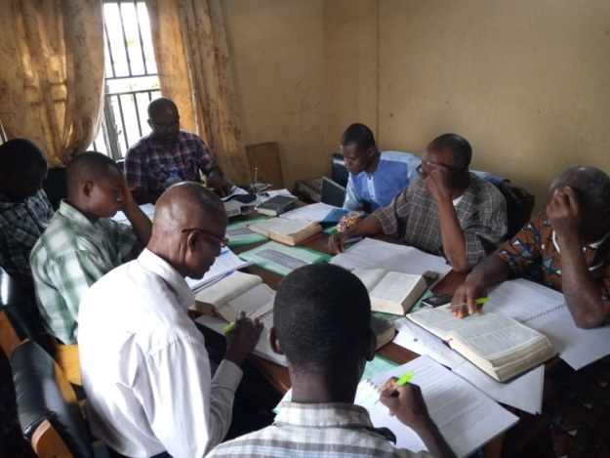
PASTORS LEADERSHIP TRAINING
In line with the goal of TETMI to develop it core human resource in capacity, an intensive Leadership Training was held for our major mission personnel (pastors). This training was aimed at helping them develop skills to be effective in their personal lives and ministry. This training was also aimed at helping them build spiritual capacity to face the challenges in the mission field. Financial management, personal management, people management, communication skill and Leadership skills and much more were the focal point.
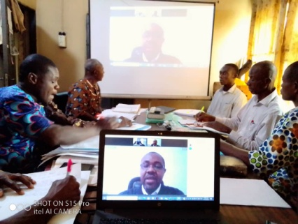
This training had lots of practical and brainstorming activities to help all participants internalize what was taught. Highly qualified personnel from within the country and outside the country facilitated this training. Our international facilitators from Kenya and Canada facilitated via Zoom.

UPCOMING EVENTS
OUTREACH TO UMUNKPOR
ISIALA NGWA L.G.A, ABIA STATE
10TH TO 13TH DECEMBER 2020
PASTORS & WIVES RETREAT
14-18TH DECEMBER 2020

